|  |
| --- |
| Øvelsesrapport: RTPD |
| Sebastian Beck  PJG511 |
| 4/12-2019 |

Index

Introduction 3

Method 3

Materials 3

Test procedure 3

Results 4

Individual differences 4

Sequenced learning occurs 4

Random learning doesn’t occur 6

Low RT due to skill 6

Simon says: “Accuracy is best for position-task.” 7

There is a speed-accuracy trade-off 7

Conclusion 8

References 8

# Introduction

Some learned skills are near impossible to explicate but can still be carried out without a hitch. According to Knowlton (1996) learning happens in different learning systems. These systems are not necessarily in sync, which means that some skills can be acquired non declaratively before a person is able to verbalise what has been learnt (Purves et al., 2013).

Simon (1969) investigated the effect of having to react either towards or away from the source of stimulation. It was found that reaction times (RT) were lower when they were congruent with the stimuli and no *translation* of movement had to happen (Simon, 1969).

In our experiment, we investigate the learning of motor skills, and if the type of task is influencing the learning. We hypothesize that RT will gradually be lowered throughout the experiment. Furthermore, we hypothesize that RT will be lower and accuracy higher for position-stimuli than for digit-stimuli, due to the Simon-effect. Even though the participants are not aware of the sequence, we hypothesize that RT are lower for the sequenced trails than for the random trails. Lastly, we expect to see a speed-accuracy trade-off.

# Method

This experiment included *N* = 218 participants, all psychology students at UCPH. Age and sex differences were not considered.

## Materials

* E-Prime® experiment file containing RTPD experiment
* PC
* Questionnaire

## Test procedure

Present during the experiment was only the participant (P). The experiment is computer based and all instructions are incorporated into the experiment. During the experiment, P operates the keyboard using the index and middle finger of each hand. Left hand for keys C (= 1) and V (= 2), right hand for key B (= 3) and N (= 4). P are randomly chosen to start with either the position- or digit-task. Both tasks consist of 20 blocks with 24 trails in each. During the position task, four rectangular frames are continuously shown at the centre of the screen. After 500ms a smaller black rectangle are shown within one of the frames. When the rectangle appears, P has to press the corresponding key as quick and accurate as possible. The digit task is similar to the position task. It differs by showing a digit from 1-4 on the screen, instead of frames. When the digit appears, P has to press the corresponding key as quick and accurate as possible.

Between the two tasks a questionnaire is given, examining if P noticed a pattern and if it can be named.

# Results

## Individual differences

Figure 1: Average RT in each block for all (N = 218) participants

## Sequenced learning occurs

As illustrated in figure 1, RT seems to decrease steadily across block 1-4. A repeated measures ANOVA was used to test if the decrease was significant. This showed significant main effects of stimulus type, *F*(1, 217) = 493.66, *p* < .001, $η_{p}^{2}$ = .70, and block number, *F*(1.27, 276.49) = 91.50, *p* < .001, $η_{p}^{2}$ = .30 (Huyhn-Feldt corrected), and a significant interaction between stimulus type and block number, *F*(1.36, 294.76) = 5.96, *p* = .01, $η_{p}^{2}$ = .03.

The main effect of block number and stimulus type shows a difference in RT depending on block number and which stimulus type. The interaction means this difference varies dependent on stimulus type. In figure 1 we see that RT for position on average is lower than for digits, but both stimulus types see a decrease in RT. This supports our learning and Symon-effect hypotheses.

To examine if the order of stimulus type had an effect, a repeated measures ANOVA was used. This showed a significant main effect of stimulus type, *F*(1, 216) = 97.52, *p* < .001, $η_{p}^{2}$ = .31, but no significant main effect of order, *F*(1, 216) = 1.06, *p* = .31, $η_{p}^{2}$ = .01. There was a significant interaction between stimulus type and order, *F*(1, 216) = 13.32, *p* < .001, $η_{p}^{2}$ = .06.

The main effect of stimulus type indicates that all P on average had a higher RT on digit than position. The interaction between stimulus type and order indicates that learning transfer between tasks. P are on average faster at a task if they tried the other task first. Still, position is always faster than digit, as illustrated in figure 2.

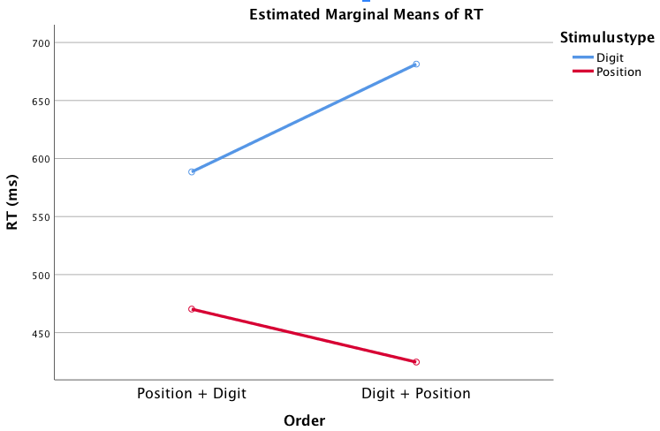

Figure 2: Interaction between stimulus order and type in the first block

## Random learning doesn’t occur

Figure 3: RT for each block in each task for FP19203

As indicated in figure 3, learning doesn’t seem to occur for random blocks. To test this, a repeated measures ANOVA was used to compare RT of the random blocks. This showed a significant main effects of stimulus type, *F*(1, 217) = 956.99, *p* < .001, $η_{p}^{2}$ = .82, and random block, *F*(2.48, 539.10) = 5.49, *p* = .002, $η_{p}^{2}$ = .03 (Huyhn-Feldt corrected), but no significant interaction between stimulus type and random block, *F*(2.67, 578.30) = 0.12, *p* = .93, $η_{p}^{2}$ = .001 (Huyhn-Feldt corrected). The main effect of stimulus type shows that RT is faster for position than for digit, even during the random blocks (figure 1+2). The main effect of random block shows that the RT does variate between the blocks. The lack of interaction shows that learning isn’t transferring to the random blocks.

## Low RT due to skill

Not everything is due to learning. To see if some P were just naturally skilled at the tasks, a two-tailed Pearsons correlation test was used. It showed a significant positive correlations between digit and position conditions for blocks 1 (fixed), *r*(216) = .22, *p* = .001, for blocks 19 (fixed), *r*(216) = .30, *p* < .001, and for blocks 20 (random), *r*(216) = .54, *p* < .001. This means that P with the lowest RT in block 1, also had the lowest RT in block 19. This is even more noticeable in the last random block, where learning doesn’t influence the RT.

## Simon says: “Accuracy is best for position-task.”

The Simon-effect states that accuracy should be highest in the position-task, since no translation has to be made. A repeated measures ANOVA was used to test this. It showed significant main effects of stimulus type, *F*(1, 217) = 30.26, *p* < .001, $η_{p}^{2}$ = .12, and sequence type, *F*(1, 217) = 133.31, *p* < .001, $η_{p}^{2}$ = .38, but no significant interaction between stimulus type and sequence type, *F*(1, 217) = 3.10, *p* = .08, $η_{p}^{2}$ = .01. This supports the Simon-effect hypothesis. The main effect of stimulus type indicates a difference in accuracy for each of the stimulus types. Figure 4 shows that accuracy is for position, even in the random trails. The main effect of sequence indicates that accuracy varies for fixed and random sequences. This is illustrated in figure 4.

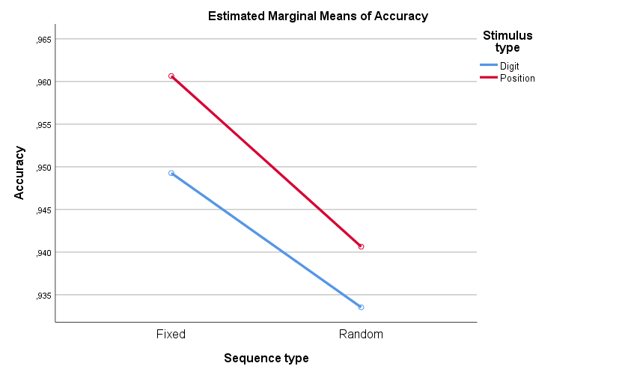

Figure 4: Accuracy for each condition and stimulus type.

## There is a speed-accuracy trade-off

To test for a speed-accuracy trade-off, a two-tailed Pearsons correlation was used. This showed significant positive correlation between accuracy and RT for both random digit condition, *r*(216) = .28, *p* < .001, and random position condition, *r*(216) = .36, *p* < .001. This supports the speed-accuracy hypothesis, in which higher accuracy together with slower RT.

# Conclusion

This experiment has shown that skills can be acquired non declaratively. RT was gradually lowered for the fixed blocks, but not for random blocks. Furthermore, RT was lower and accuracy higher for the position-task, which could be due to the Simon-effect. Finally, a speed-accuracy trad-off was shown.

# References

Knowlton, B. J., Mangels, J. A., & Squire, L. R. (1996). A Neostriatal Habit Learning System in Humans. *Science*, *273*(5280), 1399–1402.

Purves, D., Cabeza, R., Huettel, S. A., LaBar, K. S., Platt, M. L., & Woldorff, M. G. (2013). *Principles of Cognitive Neuroscience* (2nd ed.). Sunderland, Massachusetts: Sinauer Associates, Inc., Publishers.

Simon, J. R. (1969). Reactions toward the source of stimulation. *Journal of Experimental Psychology*, *81*(1), 174–176.